Basic Qaida
1, Page Number 12 .excerise of zabar phly ay ge then excerise of zair ay ge
: Done
2, page 30 jazam or sukoon
letters main ager thora sa sapce ajay
: Done
3, page number 37/38 without shadd waly word remove krnay hain
: Done
Advance Qaida
page No 50 first line 3rd word yanaaouna hay
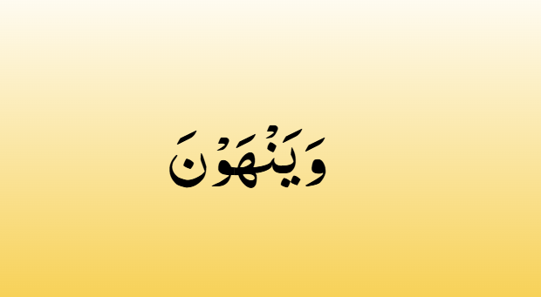
: Done
page number 58 and 59 tnween with lamm and raa seprate hona chahy Tanween with ya meem noon wao seprate hona chahy
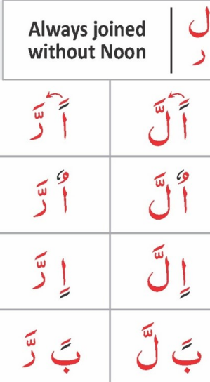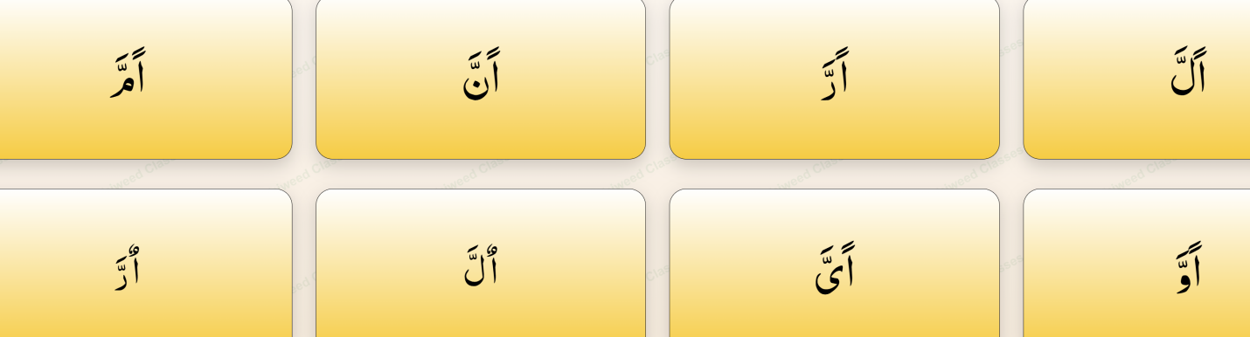
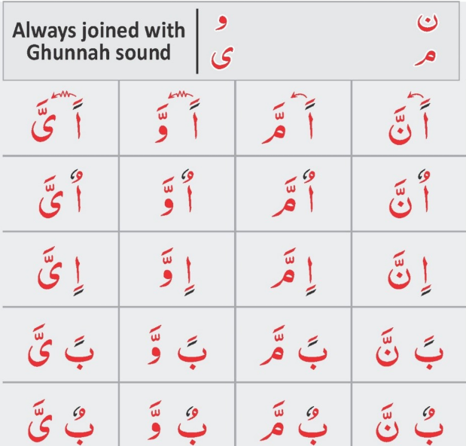
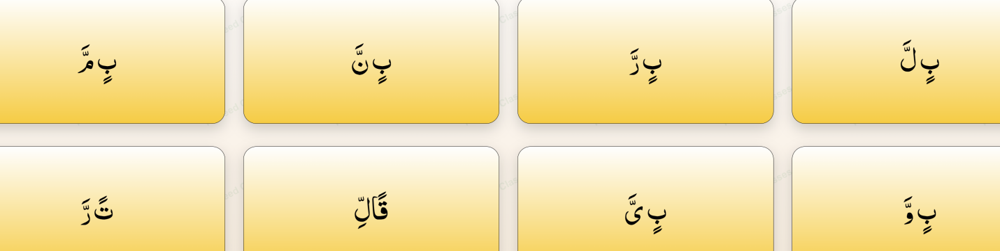
page number 60 & 61 1 page per ay ga aik excerise hay
page number 62 instruction add krna hy
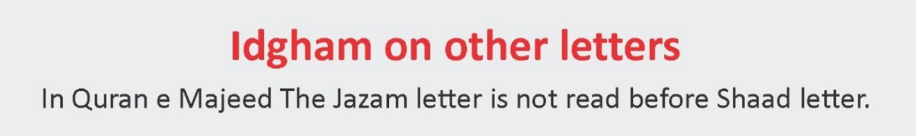
ye add krna hy
: Done
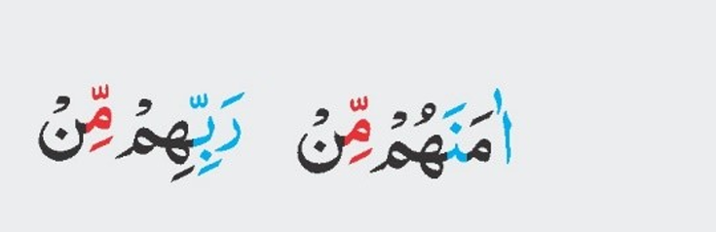
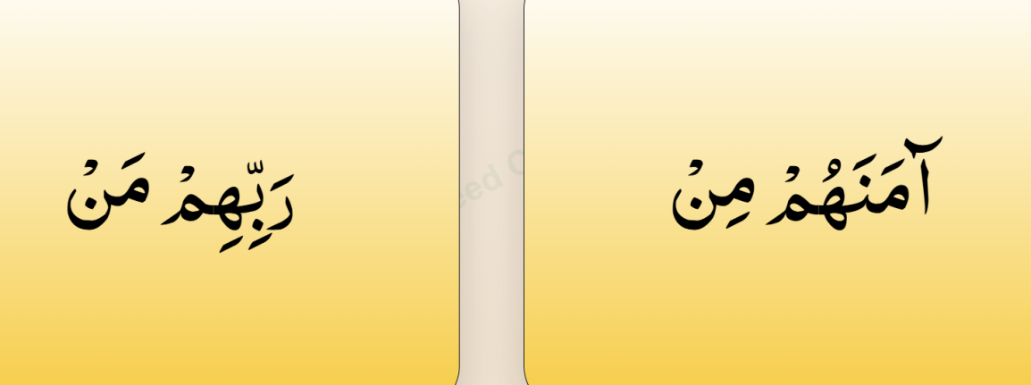
tashdeed sighn on 2nd meem : Done
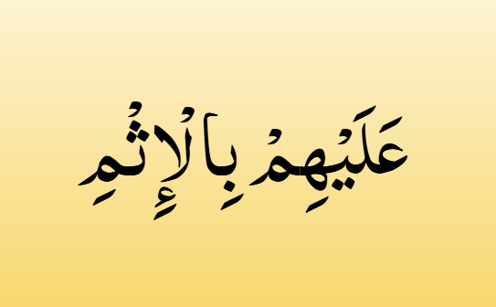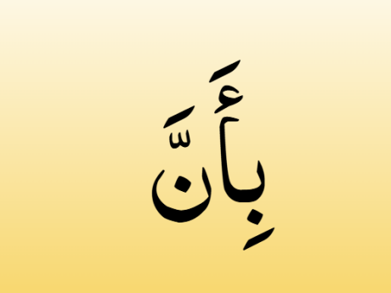
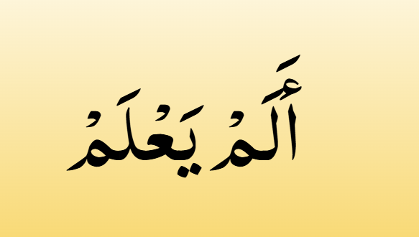
Remove Hamz all of them page
: Done
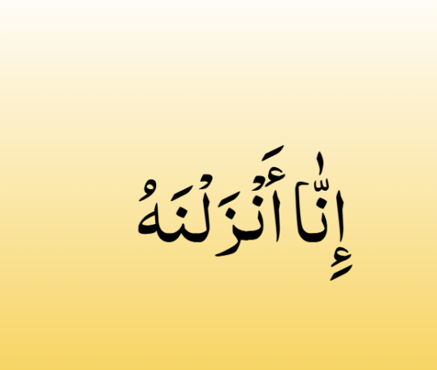
page no 69 remover zabar from NOON ZABAR place erected zabar on it
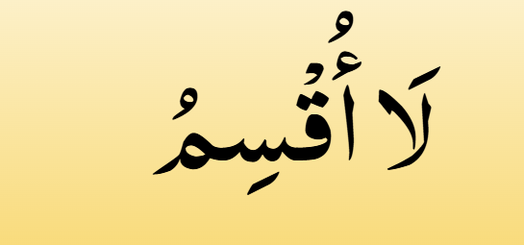 page 69 Remove Hamza on alif
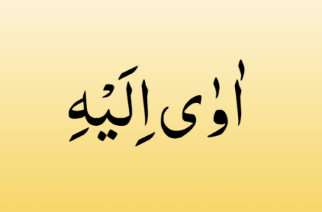 page 69 place madd sign on wao
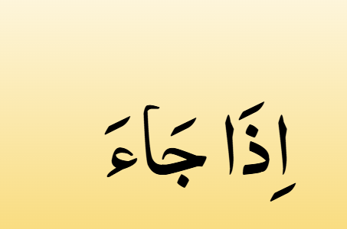pag no 69 Madd sign on jeem alif madd zabar jaaa
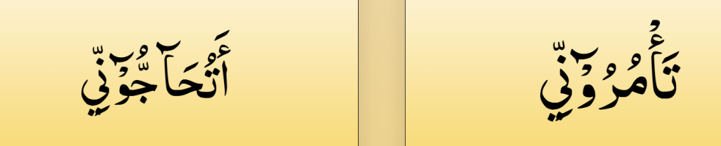
pag number 70 remove 2 dots on yaa both of them
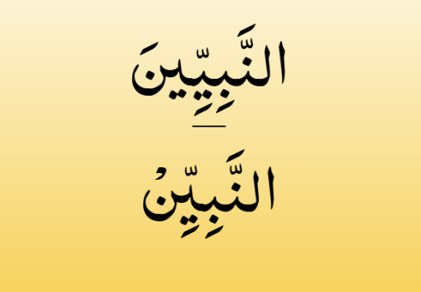
page no 71 2nd word per madd lgana hy
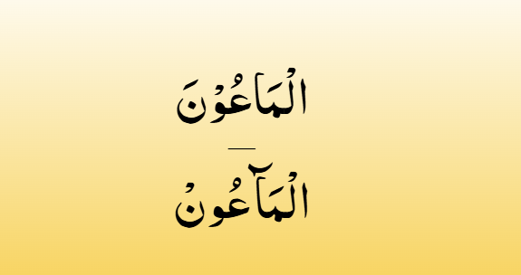
pag no 72 madd sign 2nd word wala wao per ay ga
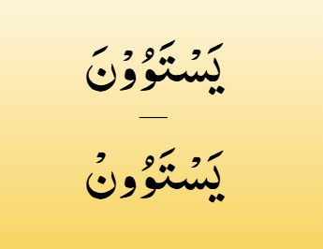
2nd word per madd sign ay g wao per

page 72 per ye instruction add krna hy

page 73 instruction wrong hy
example of pause due huroof-e- leen
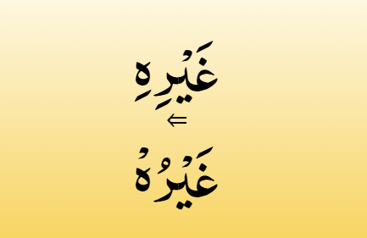
remove paish add zair on 2nd word of raa :Done
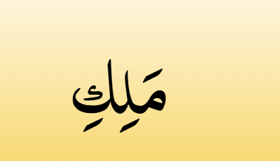
page 77 meem standing zabra maaa hy : Done
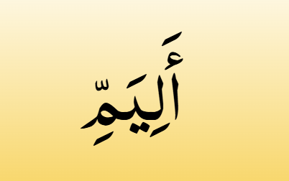
pag 79 lamm k neachy say zair remove hoga :Done
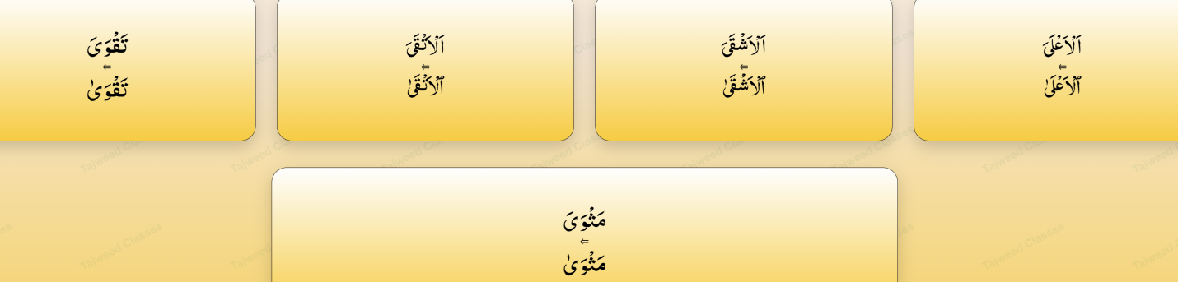
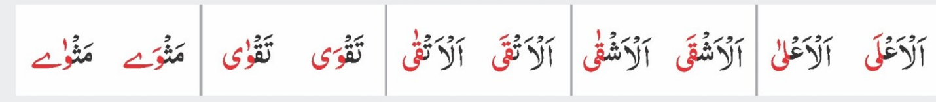
page number 80 last k letter sy sighns remove hongy : Done

